Creating balance in our lives is an important part of wellness. While a perfectly balanced Wellness Wheel is unlikely, thanks to the different demands we face at different points in life, we do need a fairly balanced wheel, because it's hard to drive on a flat tire.

The dimensions of wellness are ideals, not standards or fixed goals. We have individual needs, beliefs, and capabilities, so what you consider balanced wellness will look different from another person’s view. And your view of wellness will even look different during different stages of your life. The goal is to find a personal balance that is most authentic for you at this point in your life. Balancing wellness is an ongoing process. Disruptions in your routines and habits (from stress, illness, trauma, emotional challenge, etc.) can cause disruptions in wellness. In such "unbalanced" times, it's important to determine the areas of life that need your attention. Identify your high spots and low spots that are creating a bumpy ride. Refocusing on positive habits and routines will help you regain control of your wellness and move from surviving to thriving in a way that fits your individual needs.

This activity has been adapted from “Balancing Your Wellness Wheel: Self-Assessment” by Jean E. Berry (MS, Clinical Mental Health Counseling)
and Laura B. Demers (M Ed, Curriculum and Instruction). The full activity is available in their Etsy shop.

Step 1. Read about the Eight Dimensions of Wellness: Begin by reading the following article about the eight dimensions of wellness, Mapping Mental Health: Dr. Swarbrick & The Eight Wellness Dimensions. The article provides a brief history of the development of the eight dimensions of the wellness model.
Step 2. Score Each Dimension of Wellness: First, read the definition of each dimension of wellness. Use our Guiding Questions to help yourself assess your life and determine an appropriate score. Pick the statement that best describes your current level of wellness for each dimension and place an x in the corresponding cell.
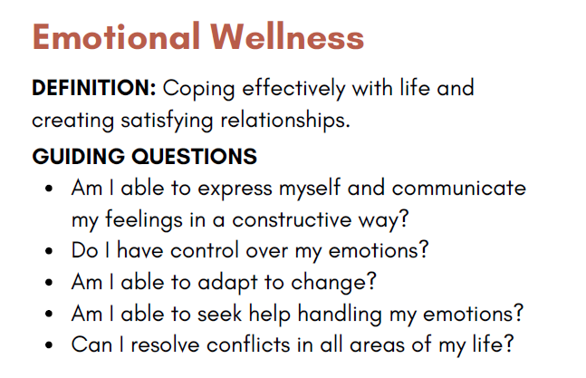 | 1  I own this weakness. I know I definitely need to work on this. | 2  I admit this area isn't great. I can do better here. | 3  This part of my life is pretty solid, but I know I can improve. | 4  I'm satisfied with this. Maybe I can do more, but I'm not sure how. | 5  I'm completely fulfilled in this part of my life. This is a strength area.

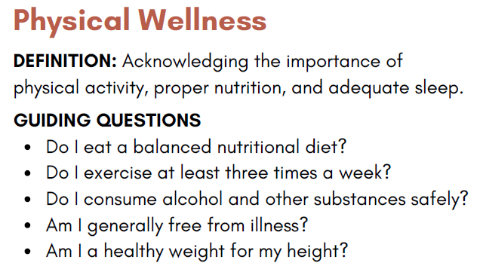 | 1  I own this weakness. I know I definitely need to work on this. | 2  I admit this area isn't great. I can do better here. | 3  This part of my life is pretty solid, but I know I can improve. | 4  I'm satisfied with this. Maybe I can do more, but I'm not sure how. | 5  I'm completely fulfilled in this part of my life. This is a strength area.

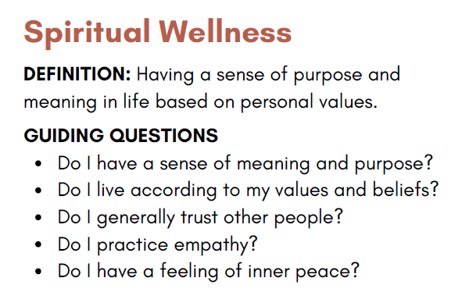 | 1  I own this weakness. I know I definitely need to work on this. | 2  I admit this area isn't great. I can do better here. | 3  This part of my life is pretty solid, but I know I can improve. | 4  I'm satisfied with this. Maybe I can do more, but I'm not sure how. | 5  I'm completely fulfilled in this part of my life. This is a strength area.

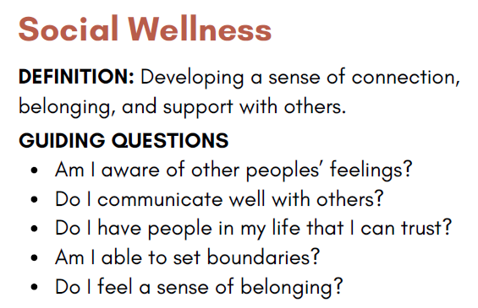 | 1  I own this weakness. I know I definitely need to work on this. | 2  I admit this area isn't great. I can do better here. | 3  This part of my life is pretty solid, but I know I can improve. | 4  I'm satisfied with this. Maybe I can do more, but I'm not sure how. | 5  I'm completely fulfilled in this part of my life. This is a strength area.

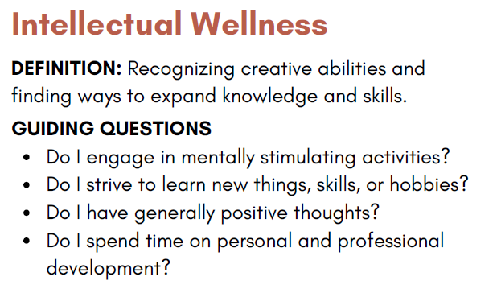 | 1  I own this weakness. I know I definitely need to work on this. | 2  I admit this area isn't great. I can do better here. | 3  This part of my life is pretty solid, but I know I can improve. | 4  I'm satisfied with this. Maybe I can do more, but I'm not sure how. | 5  I'm completely fulfilled in this part of my life. This is a strength area.

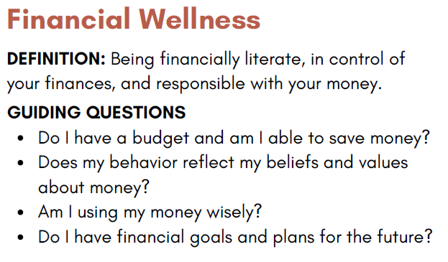 | 1  I own this weakness. I know I definitely need to work on this. | 2  I admit this area isn't great. I can do better here. | 3  This part of my life is pretty solid, but I know I can improve. | 4  I'm satisfied with this. Maybe I can do more, but I'm not sure how. | 5  I'm completely fulfilled in this part of my life. This is a strength area.

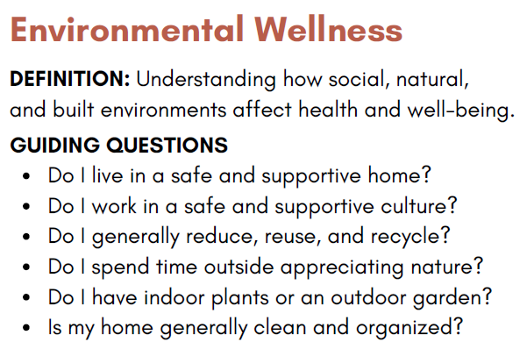 | 1  I own this weakness. I know I definitely need to work on this. | 2  I admit this area isn't great. I can do better here. | 3  This part of my life is pretty solid, but I know I can improve. | 4  I'm satisfied with this. Maybe I can do more, but I'm not sure how. | 5  I'm completely fulfilled in this part of my life. This is a strength area.

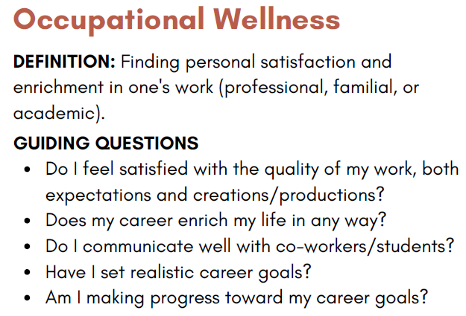 | 1  I own this weakness. I know I definitely need to work on this. | 2  I admit this area isn't great. I can do better here. | 3  This part of my life is pretty solid, but I know I can improve. | 4  I'm satisfied with this. Maybe I can do more, but I'm not sure how. | 5  I'm completely fulfilled in this part of my life. This is a strength area.

Step 3. Analyze your Results: Score your wellness self-assessment. Utilize your wellness self-assessment score to take note of the gaps (highs and lows).
Record your score for each dimension below |  |  | What were your two lowest-scoring dimensions?
Emotional: | Intellectual: |  | What were your two lowest-scoring dimensions?
Physical: | Financial: |  | What were your two lowest-scoring dimensions?
Spiritual: | Environmental: |  | What was your highest-scoring dimension?
Social: | Occupational: |  | What was your highest-scoring dimension?

Low Spot Reflection: Complete the sections below based on your two lowest-scoring dimensions.
Dimension 1
What does this area of your life look like right now?
Was this area ever in better condition? If so, what happened to allow/enable deterioration?
What is your ideal vision for this dimension in your life?
How would improvement in this dimension improve your life?

Dimension 2
What does this area of your life look like right now?
Was this area ever in better condition? If so, what happened to allow/enable deterioration?
What is your ideal vision for this dimension in your life?
How would improvement in this dimension improve your life?

Strength Reflection: Complete the sections below based on your highest-scoring dimension.
Strength Dimension
What does this area of your life look like right now? In what ways is this a strength area?
What are you most proud of from this dimension of your life?
Is this dimension consciously important to you? In other words, are you thankful that this dimension scored the highest because you put effort into this area, or is it a sort of accidental/unintentional strength?
Look back at the Wellness Wheel: Definitions & Guiding Questions page. Did you answer "no" to any of the guiding questions? If so, which question(s)?
What can you do to turn the "no" responses into "yes" responses?

Step 4. Create a Self-care Action Plan: Consider different ways to address any high or low spots of your wellness. Try out some changes in your routines and lifestyle choices until you find what works for you. Commit to making positive changes and developing healthy new habits in all eight dimensions of wellness in order to reach your optimal health. Develop your self-care plan by brainstorming which people, programs, and activities that can help to support your wellness for each domain. List a specific goal for each domain.
Dimension | People | Program(s) | Activities | Specific Goal
Emotional
Physical
Spiritual
Social
Intellectual
Financial
Environmental
Occupational

Step 5. Plan for Self-accountability: Create one self-care goal to focus on over the next month and write it below. Consider why this goal is important to you and how you will track your progress. Will you use a habit tracker, write reflections in a journal, or find another method that helps you stay consistent and motivated?

Wellness is a lifelong journey that evolves as you do. By reflecting honestly on each dimension of your well-being and identifying both areas of strength and areas for growth, you are taking an important step toward greater balance and fulfillment. Remember that small, consistent actions lead to lasting change. Revisit your self-care plan often, celebrate your progress, and be gentle with yourself as you continue to grow. Each choice you make to care for your mind, body, and spirit contributes to a healthier, more vibrant you.

